**Template for Evidence(s)**

**UI GreenMetric Questionnaire**

University : …..

Country : ….

Web Address : ….

**[1] Setting & Infrastructure**

**[1.8] The ratio of open space area to total area**

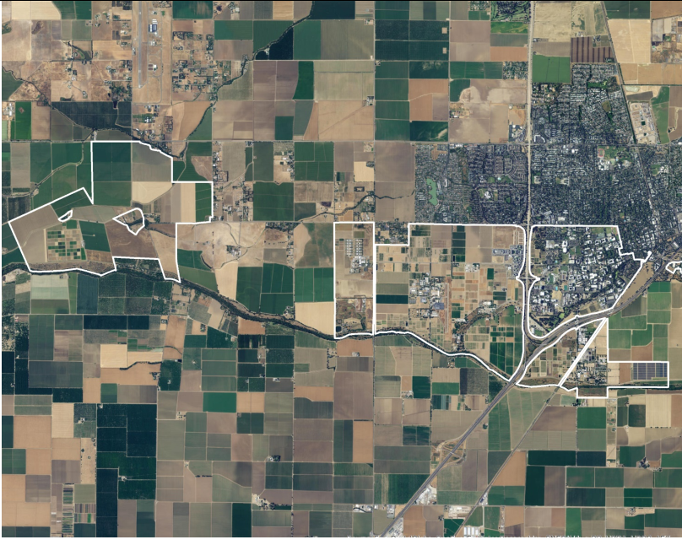

**Description:**

Ratio of open space towards total area: 96%

|  |  |  |
| --- | --- | --- |
| Openspace name | Total area | Duration (in Hours per Weeks) |
| Open Space Preserve | 1.360.000 m2 | 84 |
| Putah Creek Riparian Reserve | 2.590.000 m2 | 168 |
| UC Davis Arboretum | 404.686 m2 | 168 |

*Example from University of California, Davis

**Additional evidence link (i.e., for videos, more images, or other files that are not included in this file):**